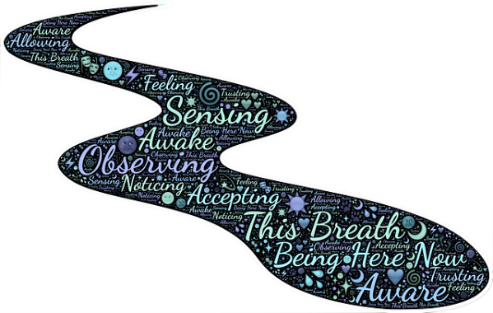
2023 SDCA SPRING CONFERENCE
Mental Health is as important as Breathing!
Sheraton Hotel and Sioux Falls Convention Center,
Sioux Falls, SD

CALL FOR PROGRAMS FORM

Content Sessions will be presented Friday, April 21 and Saturday, April 22, 2023. Please note, all breakout sessions will be limited to 60 minutes.
(Please complete and send electronically as a Word document attachment.)

Presentation Title:

Program Description (include rationale, program goals, delivery method, and connection to conference theme. (Maximum 1500 characters):

Learning Objectives (include at least three – must be measurable and specific):

Program Summary for Publication in Conference Program (Maximum of 500 characters):

Tie the presentation to minimally one (can choose more) of the NBCC Core Content Areas:

- Counseling Theory/Practice and Counseling Relationship
- Human Growth and Development
- Social and Cultural Foundations
- Group Dynamics and Counseling
- Career Development and Counseling
- Assessment
- Research and Program Evaluation
- Counselor Professional Identity and Practice Issues
- Wellness and Prevention

Does your presentation apply to both mental health counselors and school counselors? If so, how is it applicable to both?

RESUME/VITAE OF EACH PRESENTER ARE REQUIRED FOR CONTACT HOURS & MUST BE INCLUDED FOR CONSIDERATION. PRIMARY PRESENTER MUST HOLD AN ADVANCED DEGREE IN COUNSELING OR A COUNSELING RELATED FIELD.

Presenter(s)Name and Credentials:

Presenter(s) Work Setting:

Is your SD Counseling Assoc. membership current? __Yes __ No

Email Address for Primary Presenter:

SUBMISSION DEADLINE FOR ALL PROGRAMS IS December 2, 2022

Submit the proposal and resumes electronically to sdca2021conference@gmail.com
Email submissions are preferred; however paper proposals will also be accepted.

If Unable to Submit Electronically, Mail Program Proposals with Resumes/Vitaes To:
SDCA
PO Box 95
Aberdeen, SD 57402-0095

(Proposals received after the deadline will only be considered if space is available.)

Please read the following so you are aware of the “Call for Programs Criteria.” By submitting a program you are affirming you have read and understand the following:

Call for Programs Criteria

- Programs must comply with the NBCC’s Approved Content Areas: Counseling Theory/Practice and the Counseling Relationship, Human Growth and Development, Social and Cultural Foundations, The Helping Relationship, Group Dynamics and Counseling, Career Development and Counseling, Assessment, Research and Program Evaluation, Counselor Professional Identity and Practice Issues, and Wellness and Prevention.

- Primary presenters MUST hold an advanced degree in Counseling or a Counseling related field. Please email sdca.counseling@gmail.com with any questions.

- All presenters must register for the Conference and pay the appropriate registration fees. Waivers can be granted by the Education Committee.

- Each presenter must furnish his/her own handouts free of charge and/or provide access, electronically (e.g., email attachment) or otherwise to participants.

- Presentations and related materials such as handouts and their use must conform to the current ACA Ethical Code, especially those guidelines related to G.5. Publication (e.g., G.5.a. Use of Case Examples).

- If you must cancel your program, please email the SDCA at sdca.counseling@gmail.com as soon as possible.

